MSc Artificial Intelligence Research Proposal

A Multi-Signal Framework for Detecting Knowledge Decay in Enterprise Knowledge Bases Using Authoritative Source Comparison

Introduction
The increasing adoption of cloud computing, Artificial Intelligence (AI) and Digital Transformation is making it harder for organizations to keep their technical knowledge up to date. The continuous release of new versions of software, increased focus on security and features in addition to constant changes to best practices is causing technical documentation to lose relevance faster than ever before. This problem is often referred to as "Knowledge Decay" (Tu et al., 2024).
IT Professionals in large organizations use both official vendor documentation as well as third-party resources when deploying, configuring and maintaining enterprise systems. While official documentation will be the authoritative source of Information regarding the System(s) being used, third party articles will typically provide easier to understand explanations, practical steps to implement solutions, troubleshooting guidance and real world experience that can enhance usability. Unfortunately these types of documents are rarely updated after they are published and as such, they may still reference obsolete technologies and/or depreciated methods for implementing solutions.
Therefore, determining if technical documentation still aligns with current authoritative sources has become one of the most significant challenges facing Enterprise Knowledge Management (Gao et al., 2023).
Recent advances in Natural Language Processing (NLP), semantic retrieval and Retrieval-Augmented Generation (RAG) have made it possible for AI-based systems to search and reason about Enterprise Knowledge much better than previously (Lewis et al., 2020; Gao et al., 2023).
However, while there has been recent research into the areas of Information Retrieval, Semantic similarity and factual verification of knowledge within enterprises, very little Research exists specifically examining how to automatically assess how outdated an organization's Technical Documentation is compared to its authoritative sources (Yu et al., 2026; Tu et al., 2024).
Based on the identified research gap, this study seeks to answer the following research question:
“How can a multi-signal AI framework detect knowledge decay in enterprise knowledge bases through authority source comparison?”

Problem Statement
In today's technological world, organizations are increasing their reliance upon digital libraries of technical knowledge (documentation), and/or other digital library resources to assist in deploying, managing, and supporting organization-wide IT Systems. With new cloud-based systems, continuous releases of features/updates to security, and constant changing in "best practices" for implementing new technology, it can be difficult for organizations to maintain up-to-date, high-quality technical knowledge. Therefore, what was once considered technically correct will begin to become less relevant due to lack of maintenance/updating and thus create a disparity between documented knowledge and authoritative guidelines.
A large body of literature has recently demonstrated the detrimental effects of outdated technical knowledge on AI/enterprise knowledge bases. The studies identified have indicated that the use of stale knowledge degrades both retrieval accuracy/factual reasoning and ultimately decision making within RAG (Retrieval-Augmented Generation) systems (Yu et al., 2026). Additionally, research related to detecting outdated facts clearly indicates that knowledge is constantly evolving and therefore some type of automatic mechanism must exist to continually identify stale/deprecated knowledge rather than being completely dependent on manual maintenance. This further highlights the necessity for improved methods for evaluating the quality/reliability of organizational technical knowledge.
While the primary resource of technical authority is typically official vendor documentation, many practicing IT professionals still choose to utilize third-party technical articles due to their ability to provide simplified explanations/practical implementation guidance/troubleshooting techniques and examples from actual environments that are easier to understand than official documentation. Third-party technical articles are generally written by individuals outside of the vendor organization, therefore these articles do not receive consistent revisions as technologies evolve. Thus, third-party technical articles may include recommendations for deprecated technologies/outdated terms/obsolete procedural steps which can lead to misconfigurations/security vulnerabilities/inoperational inefficiencies.
Prior work on assessing documentation staleness generally utilizes either publication dates/metadata/manual reviews. While much more recent research has been completed in the area of AI utilizing techniques such as semantic retrieval/document similarity/detecting outdated facts, prior research generally addresses only one component of the issue at hand and does not provide a complete evaluation of how to measure the decay of knowledge contained within unstructured enterprise technical documentation. An explainable AI system designed to compare third-party technical documentation against authoritative vendor documentation while combining several types of indicators measuring knowledge decay into a single assessment would help reduce the risk associated with inaccurate/unreliable organizational technical knowledge bases and aid in better-informed technical decisions.

Motivation
To increase the reliability and credibility of enterprise technical knowledge by developing an automated means to identify out-of-date documentation through comparing sources via AI. This research is intended to support reduced risk due to obsolete technical guidance, as well as enable improved, data-driven decision-making within enterprise IT.

Aim
To design, build and test a multi-signal AI framework that will detect and measure knowledge decay in enterprise knowledge base systems utilizing authoritative source comparisons.

Objectives
- To identify the most critical indicators that contribute to knowledge decay in enterprise technical documents based on an analysis of the current body of academic research.
- To analyse the potential of two different types of comparison-based methods (semantic comparisons, and comparisons with authoritative sources) to identify outdated technical information.
- To design and implement a Multi-Signal Artificial Intelligence Framework capable of identifying enterprise technical documents that are at risk due to outdated technical knowledge, while providing an understandable "Knowledge Decay Score" explanation.
- To provide a comparative evaluation of the performance of the proposed framework compared to traditional methods of knowledge decay detection by applying suitable performance measures.

Literature Review

Domain Overview
Enterprise Knowledge Management (EKM) is designed to help organizations collect and store their knowledge to facilitate more efficient operations and better decision making. With an increasing reliance on cloud technology, artificial intelligence, and other digital transformation tools, however, organizations are finding it much harder to keep track of what they know about how their systems operate. This is due largely to a constant need for updating software, enhancing security measures, rebranding products, and implementing new methods of using products or services. The combination of all of these factors contributes to what is known as "knowledge decay" (Tu et al., 2024), or the gradual loss of organizational knowledge.

The development of natural language processing (NLP), semantic search, and retrieval-augmented generation (RAG) technology has greatly enhanced the capacity of enterprise systems to find and use existing organizational knowledge (Gao et al., 2023; Lewis et al., 2020). While this technology has greatly improved the availability of information, there still exists a large problem with regard to ensuring that the information being found by users within an organization's system is both correct, up-to-date, and trustworthy.

Existing Systems Review
Existing knowledge management systems for enterprises are employing increasing amounts of Artificial Intelligence (AI), including for enhancing data access, semantics-based searching, and for assisting decision-makers through the use of knowledge. One of the most popular methods for achieving this is through Retrieval-Augmented Generation (RAG). RAG uses a combination of large language models and semantic retrieval to enhance the factual accuracy of generated text, while reducing hallucinations (Lewis et al. , 2020). In addition, there is another method called Adaptive-RAG. Adaptive-RAG is similar to traditional RAG but it dynamically changes how it searches based upon the complexity of the user's query. This means that Adaptive-RAG can perform better than traditional RAG when performing complex queries in enterprise environments (Jeong et al. , 2024).
While these two methods greatly enhance the ability to retrieve relevant information from large volumes of data, they do not address the issue of determining whether the retrieved information is outdated.
In recent years, researchers have studied ways to determine whether technical knowledge contained in enterprise documentation has become outdated. Tu et al. (2024) developed a system using deep learning techniques to identify outdated information within a structured knowledge graph. Additionally, Yu et al. (2026) conducted a study that showed that when knowledge becomes outdated, it reduces the reasonability of large language models. Although both studies show that identifying outdated information is important, neither study evaluated unstructured technical documentation found in many enterprise environments.
To support semantic comparison and document retrieval, several algorithms exist which have been proven successful in measuring the similarity between sentences (Sentence-BERT [SBERT], Reimers & Gurevych, 2019) and retrieving documents semantically similar to a given document (Dense Passage Retrieval [DPR] Karpukhin et al. , 2020). While SBERT and DPR represent good starting points for building an integrated solution to evaluate document relevance, none represents an independent solution to detecting knowledge decay.
Therefore, to effectively measure knowledge decay, an integrated evaluation methodology that includes semantic comparison, as well as other factors indicative of knowledge decay will need to be developed.
Approach | Primary Purpose | Strengths | Limitations
Traditional Enterprise Search | Keyword-based document retrieval | Fast retrieval | No semantic understanding or freshness assessment
RAG (Lewis et al., 2020) | Knowledge-grounded response generation | Improves factual grounding | Depends on freshness of retrieved documents
Adaptive-RAG (Jeong et al., 2024) | Adaptive retrieval strategy selection | Better retrieval efficiency | Does not evaluate knowledge decay
DEAN (Tu et al., 2024) | Outdated fact detection in knowledge graphs | Strong structured knowledge analysis | Not suitable for unstructured enterprise documents
Enterprise AI Assistants (e.g., Microsoft Copilot) | Semantic enterprise search and assistance | Natural language interaction | Limited capability for automated knowledge decay assessment

Critical Analysis and Research Gap
The literature review indicates significant advancements in the areas of Enterprise Knowledge Management (EKM) , Semantic Retrieval and AI-based knowledge Systems. The EKM and semantic retrieval area have made substantial improvements regarding Information Retrieval through semantic searching, Retrieval-Augmented Generation (RAG) and embedded techniques. Recent studies have evaluated the effectiveness of detecting outdated facts within structured knowledge representation. In combination, these advances have contributed to increased knowledge access and factual reasoning for enterprises.
However, several drawbacks exist. Presently, most enterprise Knowledge Management Systems are designed to identify relevant information but do not evaluate whether the identified technical knowledge is still current, valid, and in alignment with vendor provided authoritative guidelines. Similarly, past research has predominantly focused on addressing semantic similarity, document retrieval or outdated fact detection as separate issues. There has been limited research exploring how the combination of these complementary technologies can be integrated into a singular, comprehensive
framework which identifies knowledge decay in unstructured enterprise technical documentation.
A lack of research currently exists to develop an Explainable AI Framework that automatically compares third party technical documentation with authoritative vendor documentation utilizing a multi-indicator approach for assessing knowledge decay. Resolving this research gap will likely enhance the dependability of enterprise knowledge bases, limit reliance on antiquated technical guidance and facilitate better-informed decisions by IT professionals. Therefore, this research addresses this gap by developing a multi-signal AI framework that assesses knowledge decay based on authoritative comparisons and explainable scoring methods.
For identifying the most relevant authoritative source documents through a semantic approach to searching instead of by lexical matching, Dense Passage Retrieval (DPR) was also chosen (Karpukhin et al., 2020). The use of a semantic retrieval approach will enable the proposed framework to find equivalent versions of Microsoft Learn documentation regardless of what title each version uses or what specific terminology each utilizes.

Research Methodology

Research Design
This research uses a quantitative approach using the Design Science Research (DSR) methodology.
Design Science Research is used here due to the fact the main aim of the project is to design, develop and assess a new AI artefact that solves a real world problem in enterprise knowledge management.
The new framework will then be tested by way of experimentation with objective performance measures to verify how effective it is in identifying knowledge decay.
The research has been carried out in an iterative manner to include; literature review, framework design, dataset collection, prototype testing, experimental evaluation, and finally data analysis.
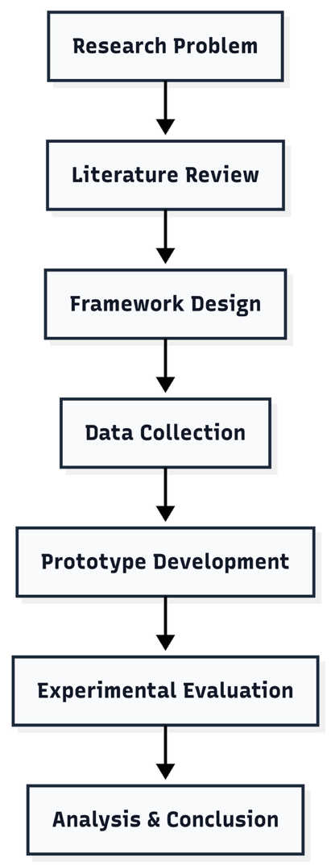

Proposed Framework
The proposed Multi-Signal AI Framework is presented in Figure 2. The framework uses a third party technical document as the entry point, obtains the appropriate official documentation for that document, conducts multi-signal evaluation of the knowledge decay score, and provides an explanation of the scores. In contrast with previous methods where there was reliance upon one method (i.e. semantic similarity) the proposed framework assesses all indicators which include; semantic similarity, terminology drift, version mismatch, temporal freshness, reference integrity, and deprecated technology.
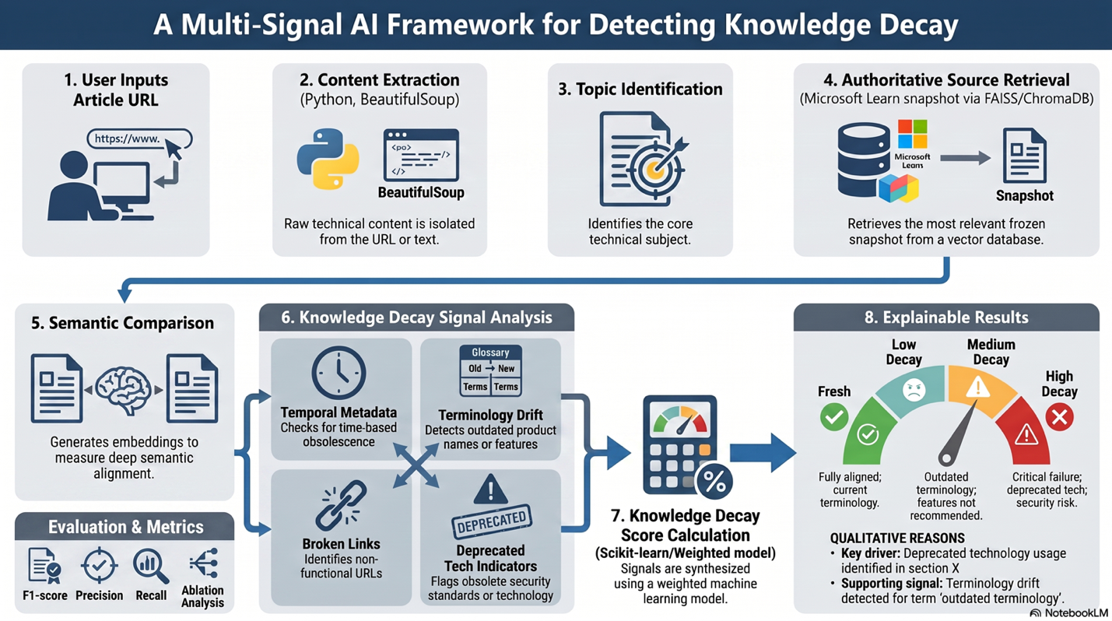

Prototype Implementation
In order to illustrate the practicability of the intended framework a functioning model based on the described concept is to be built in form of a web-frontend. The frontend allows users to input a third party technical document or URL and after submitting the document/URL they get an explainable Knowledge Decay Score which is accompanied by the single indicators that have been considered during the assessment process.
The functionality of the backend will be implemented by using python as main programming language. SBert (Semantic BERT) will be used to evaluate the semantic similarities of texts and DPR (Dense Passage Retrieval) will be used to find relevant documents from the authoritative knowledge base. The access to pre-trained language models is provided via the hugging face transformers library. The use of FAISS enables efficient similarity searches for vectors. Additionally, a lightweight streamlit frontend provides an interactive way to test the functionality of the framework. For this purpose Microsoft Learn is used as the authoritative knowledge base. Third party Microsoft documentation (publicly available) is being used as third party sources for testing purposes.

Data Collection and Management
Research data consists of third-party microsoft technical articles and corresponding Microsoft Learn documentation. The articles will be considered authoritative reference content for this research project. The collected data shall be stored in a secure password protected local development environment and used only for academic research purposes. Personal or confidential sensitive data shall not be collected or processed.

The research conducted as part of this thesis will follow the LSEP principles (legally, socially, ethically and professionally). From a legal perspective, only public accessible content shall be utilized in accordance with applicable copyright and licensing requirements. From an ethical perspective, the framework evaluates technical documentation rather than individuals or organizations, which minimises risk of bias or privacy concerns. From a social perspective, the objective of this research is to enhance reliability of enterprise knowledge and support better decision-making regarding technology. Professionally, the research will maintain integrity of the data; provide accurate citation of sources and reproducible experimental procedures.

Evaluation Strategy
The proposed framework will be tested against a manual annotation based dataset for comparison of the assessment of knowledge decay provided by this framework with actual knowledge decay. This testing will include use of precision, recall, f1 score and accuracy as metrics to evaluate the performance. Additionally an ablation study will test the contribution of each knowledge decay indicator on the total performance of the proposed framework. Evaluation will measure how well the proposed framework identifies outdated enterprise technical documents.

Time Scale
Task | Jul | Aug | Sep | Oct | Nov
Proposal Approval | ●
Literature Review | ● | ●
Framework Design | ● | ●
Dataset Collection & Labelling |  | ● | ●
Prototype Development |  | ● | ● | ●
Experimental Evaluation |  |  | ● | ●
Results Analysis |  |  |  | ●
Dissertation Writing |  |  | ● | ● | ●
Final Review & Submission |  |  |  |  | ●

Conclusion
This propsal presents a multi-signal artificial intelligence (AI) framework for detecting knowledge decay in enterprise technical documentation based upon comparisons with authoritative sources. The current research aims to address the shortcomings of existing methods, which individually rely on techniques such as semantic retrieval, document similarity analysis or identifying out-of-date facts, by presenting a methodologically integrated and transparent framework for determining whether knowledge is decaying.

The anticipated contribution of this research is the development and testing of a method that integrates a number of different indicators of knowledge decay into one unified 'Knowledge Decay Score'. It is envisioned that this would lead to improved recognition of outdated technical documentation, and thus, potentially increased reliance on reliable enterprise knowledge repositories and also more informed technical decision making. Findings from this study may be used to inform both theoretical work related to using AI to manage knowledge in enterprises and the practice of maintaining knowledge in rapidly changing technological environments.

References
Gao, Y., Xiong, Y., Gao, X., Jia, K., Pan, J., Bi, Y., Dai, Y., Sun, J. and Wang, H. (2024) Retrieval-Augmented Generation for Large Language Models: A Survey. arXiv preprint arXiv:2312.10997.

Hevner, A.R., March, S.T., Park, J. and Ram, S. (2004) 'Design science in information systems research', MIS Quarterly, 28(1), pp. 75–105.

Jeong, S., Baek, J., Cho, S., Hwang, S.J. and Park, J. (2024) Adaptive-RAG: Learning to Adapt Retrieval-Augmented Large Language Models through Question Complexity. Proceedings of NAACL 2024.

Karpukhin, V., Oguz, B., Min, S., Lewis, P., Wu, L., Edunov, S., Chen, D. and Yih, W. (2020) 'Dense Passage Retrieval for Open-Domain Question Answering', Proceedings of EMNLP 2020, pp. 6769–6781.

Lewis, P., Perez, E., Piktus, A., Petroni, F., Karpukhin, V., Goyal, N., Küttler, H., Lewis, M., Yih, W., Rocktäschel, T., Riedel, S. and Kiela, D. (2020) 'Retrieval-Augmented Generation for Knowledge-Intensive NLP Tasks', Advances in Neural Information Processing Systems (NeurIPS), 33.

Li, Y. et al. (2026) MARCH: Multi-Agent Reinforced Self-Check for LLM Hallucination. arXiv preprint arXiv:2603.24579.

Microsoft (2025) Microsoft Learn Documentation. Available at: https://learn.microsoft.com/ (Accessed: Month Year).

OpenAI (2025) GPT-4 Technical Documentation. Available at: https://platform.openai.com/docs (Accessed: Month Year).

Peffers, K., Tuunanen, T., Rothenberger, M.A. and Chatterjee, S. (2007) 'A Design Science Research Methodology for Information Systems Research', Journal of Management Information Systems, 24(3), pp. 45–77.

Reimers, N. and Gurevych, I. (2019) 'Sentence-BERT: Sentence Embeddings using Siamese BERT-Networks', Proceedings of EMNLP-IJCNLP 2019, pp. 3982–3992.

Tu, X. et al. (2024) Deep Outdated Fact Detection in Knowledge Graphs. arXiv preprint arXiv:2402.03732.

Yu, Z. et al. (2026) Knowledge Integration Decay in Search-Augmented Reasoning of Large Language Models. arXiv preprint arXiv:2602.09517.

